**Mobile Phone Shop**

## **Problem statement**

The idea behind this project is to create an application which helps to store and fetch relevant data related to the mobile shop. Use JDBC to connect with the database and the user can manipulate the data and validate records as per constraints.

**Core Module includes:**

* Java is used to connect databases and trigger queries.
* MySQL for creating tables and storing the data

**Develop the Tables using the following steps:**

**Mobile Details :**

|  |  |  |  |  |  |
| --- | --- | --- | --- | --- | --- |
| **BRAND** | **NAME** | **PRICE** | **MEMORY** | **CAMERA** | **DISPLAY** |
| Samsung | Note | 37999 | 128 | 55 | 6 |
| Apple | Iphone 13 | 77999 | 64 | 20 | 6 |
| Nokia | 8.1 | 12500 | 64 | 16 | 5.5 |
| Xiaomi | Note 10X | 16500 | 128 | 48 | 5.8 |
| Motorola | G8 | 18999 | 64 | 48 | 6 |
| Oppo | A53 | 16999 | 128 | 32 | 6.25 |
| Vivo | Y33S | 18990 | 128 | 50 | 6.5 |
| Asus | Zenfone | 12999 | 32 | 13 | 5.5 |
| Realme | Narzo | 12499 | 128 | 50 | 5.5 |
| BlackBerry | Evolve | 13950 | 64 | 13 | 5 |

**Q1**. Using JDBC, Execute a SQL query to fetch the attributes of the mobile with highest camera and lesser price from the mobile table.  
**Note : Print Results in console and Take screenshot and submit.**

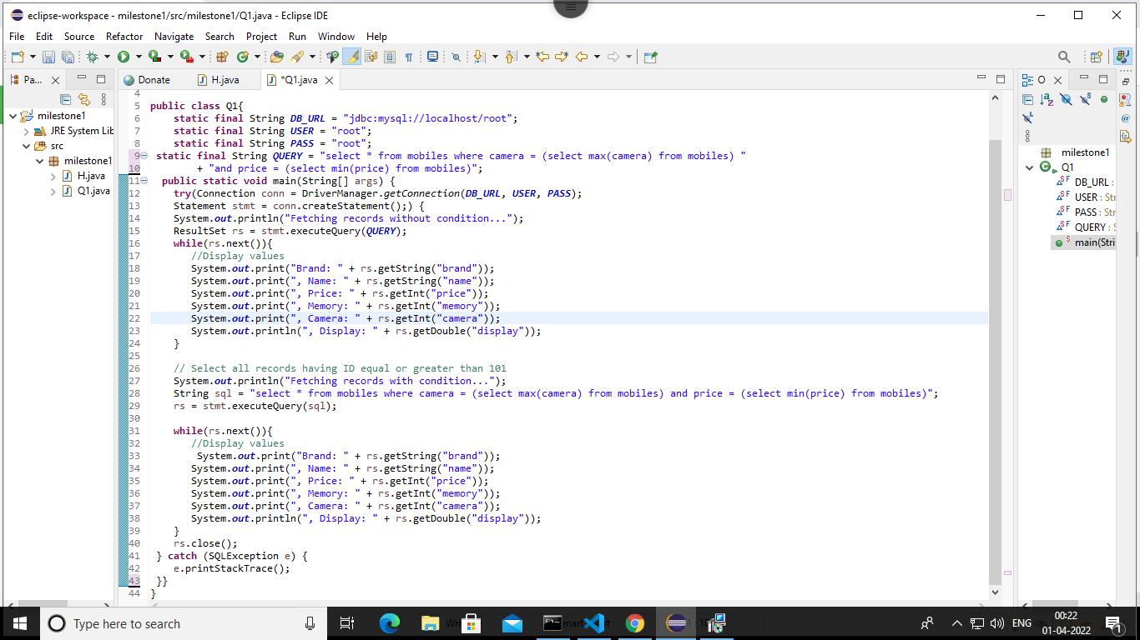

**Q2.**  Using JDBC, Execute a SQL query to fetch the name and brand of the mobile with the biggest screen size from the mobile table.  
**Note : Print Results in console and Take screenshot and submit.**

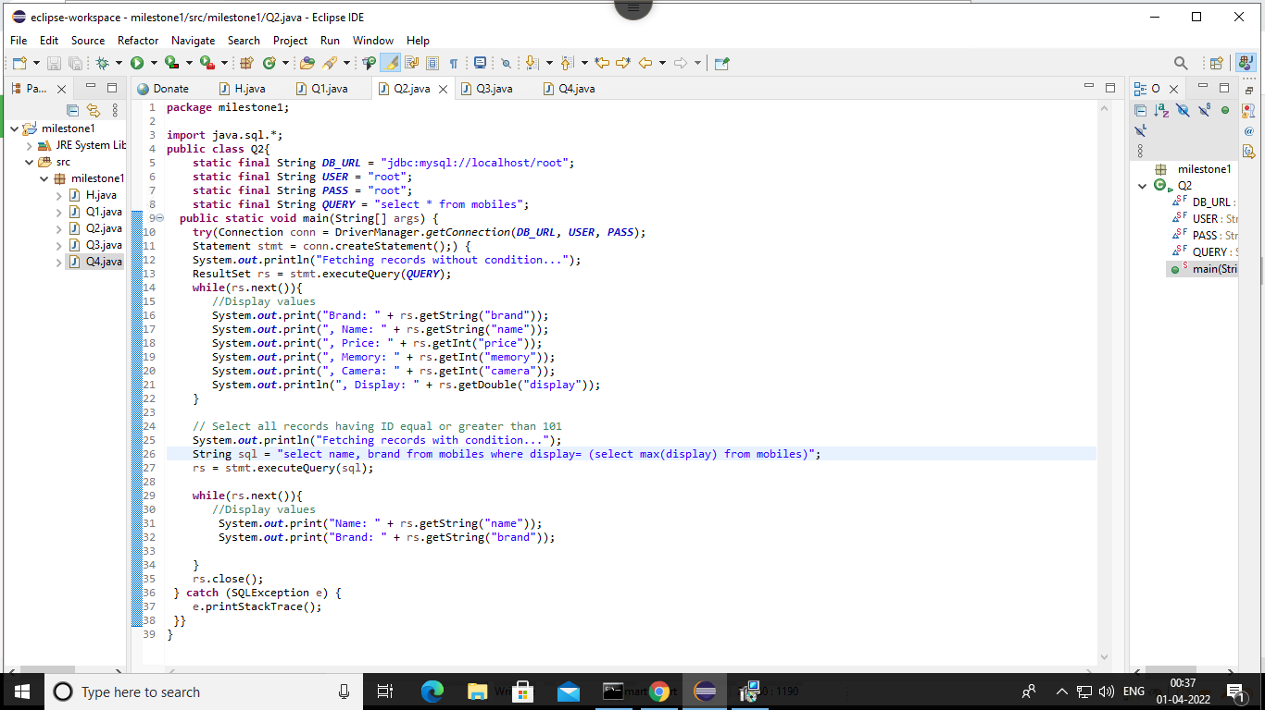

**Q3.** Using JDBC, Execute a SQL query to find the camera and price details of Apple Iphone 13 from the mobile table.

**Note : Print Results in console and Take screenshot and submit.**

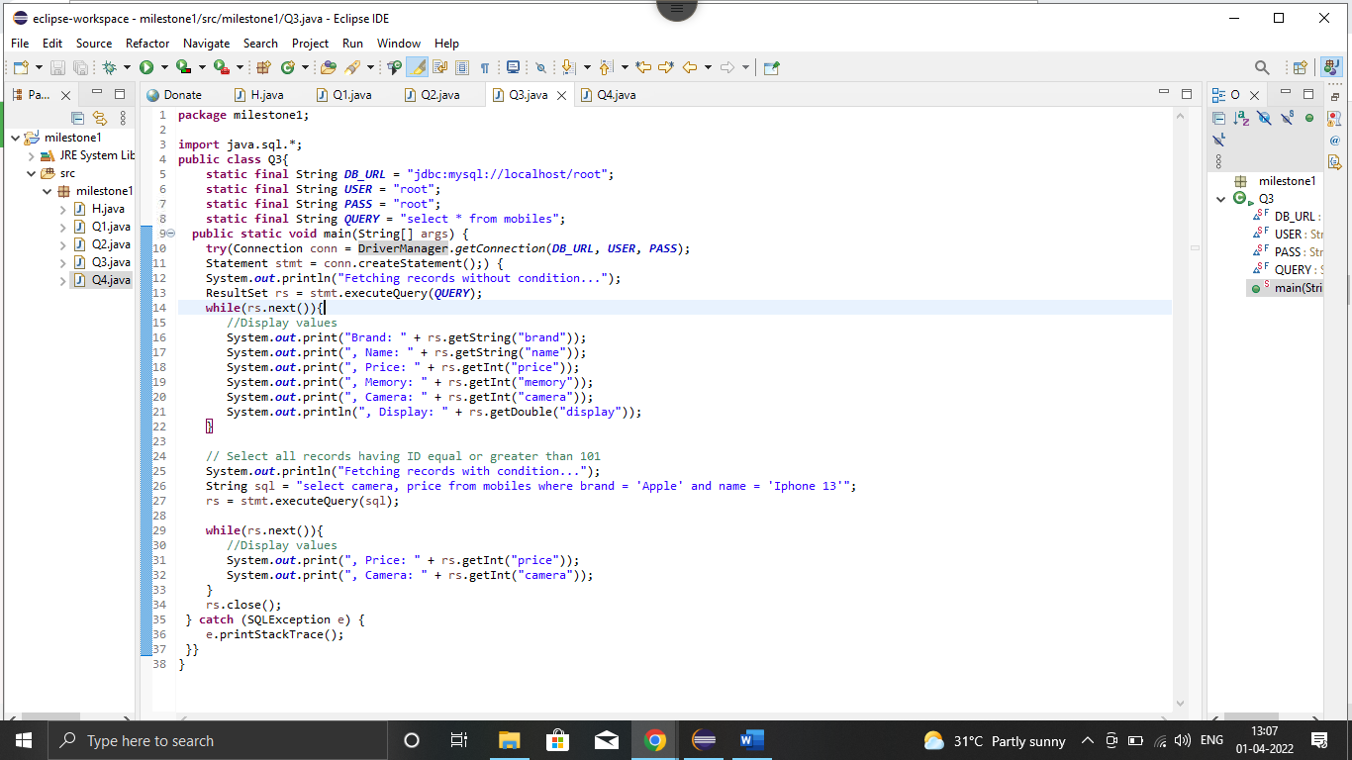

**Q4.** Using JDBC, Execute a SQL query to find the names and brands of all the phones with price from 10000 to 20000 and camera from 30-50 MP from the mobile table.  
**Note : Print Results in console and Take screenshot and submit.**

